2010 POLY Election Statements and Bios
Page 1: Complete List of Offices
Page 2-11: Candidate Statements and Bios

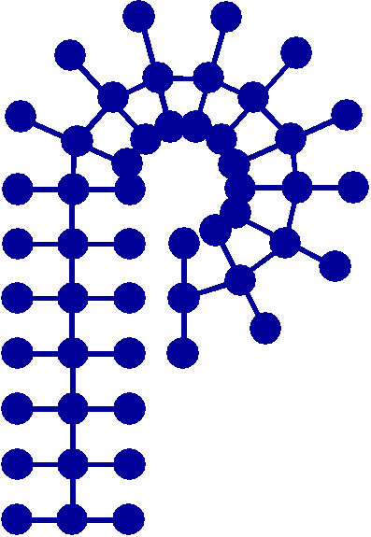
Candidate for Vice-Chair

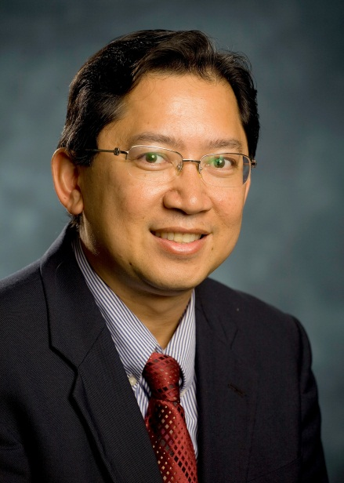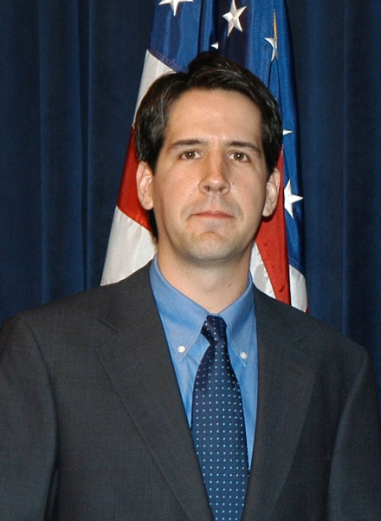
Rigoberto C. Advincula Gregory N. Tew
University of Houston University of
Massachusetts-Amherst

Candidate for Councilor

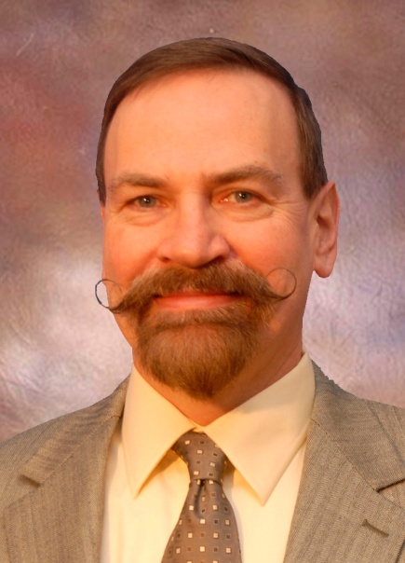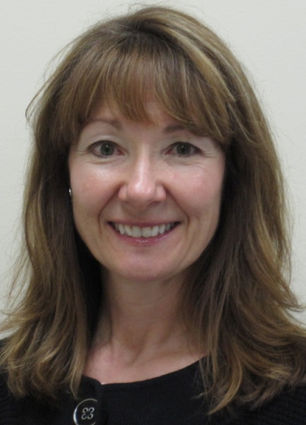
Frank D. Blum Diana J. Gerbi
Oklahoma State University 3M Company

Candidate for Secretary

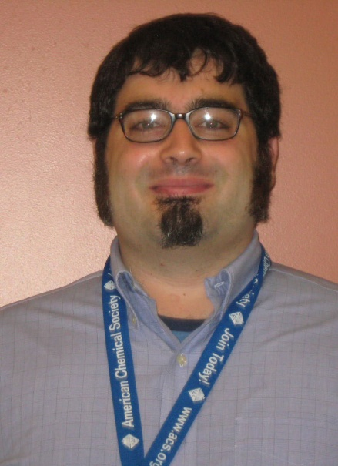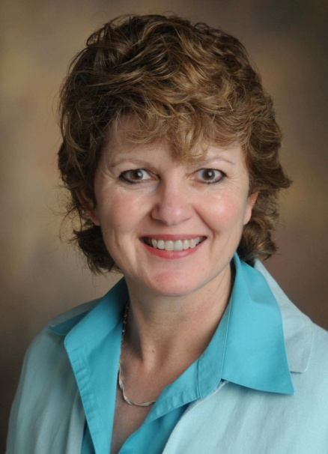
David S. Germack Sarah Morgan
Brookhaven The University of
Southern Mississippi

Candidate for Councilor

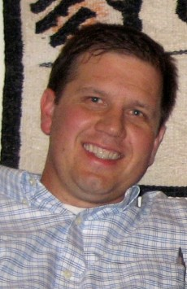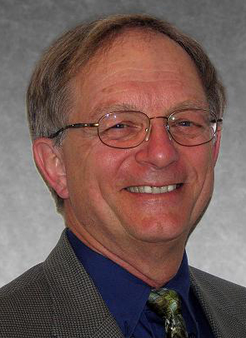
Jeffrey G. Linhardt John M. Pochan
Bausch & Lomb Cornell University

Candidate for Alternate Councilor

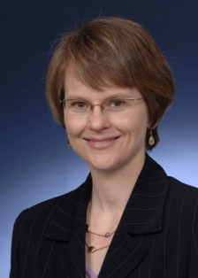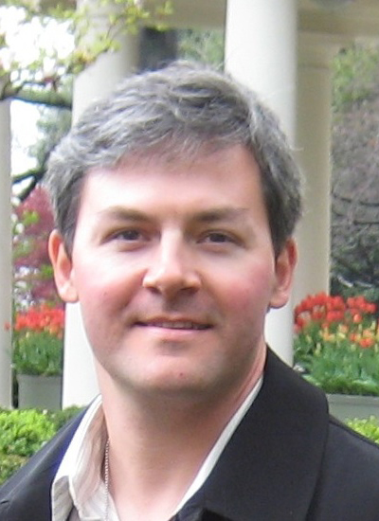
Kathryn L. Beers Stephen A. Miller
Polymers Division, NIST University of Florida

PAGE DOWN FOR INDIVIDUAL STATEMENTS/BIOS

Candidate for Vice-Chair

Rigoberto C. Advincula
University of Houston

STATEMENT: It will be an honor for me to serve the Polymer Division as your Vice Chair. I look forward, to the best of my ability, working to expand its relevance to the profession in industry, research, and education. The Vice-Chair is an important position that can help prepare the future of the Division in strategic planning and participate more actively in leading specific short-term activities. Having served for the past years as Alternate Councilor, Treasurer, Workshop Leader, Symposia Organizer, and liason to the Secretariats, I can see where the Division can better serve its members in many new and unique aspects. This includes new workshops focused to our industry members, nucleating more student organizations, highly informational web content, jobs referral services, opportunities for informal networking, international chapters, and symposia in national meetings that are of high relevance to innovation and training. I am extremely proud of our Division and how we try to strive to serve our members and bridge with other organizations. The training opportunities we can offer to our members are unique, especially with tutorial workshops and programming at national meetings that helps our members learn the state-of-the-art or simply back-to-basics. The student chapters on the other hand allow us to get “them hooked to POLY” while they are young, just like me! There are also a number of opportunities for collaborative symposia and activities with polymer societies in Asia, Americas, and Europe. I have co- organized MACROMEX 2008 and POLYMAT 2008, two successful events that galvanized fraternity with colleagues in Mexico and Japan. We are planning for a similar event with Korea next year. We should take advantage of this as a division, building bridges beyond the American Chemical Society and therefore help make POLY a truly international organization. Please feel free to let me know of your suggestions, plans, and aspirations for POLY. Your voice is important and I would like to respond to your suggestions as your Vice Chair.

BIOGRAPHY: Prof. Rigoberto Advincula or “Gobet” has recently been inducted as Fellow of the American Chemical Society, 2010. At 42 he, is one of the youngest Fellows. He has been invited twice by the National Academies of Science and Engineering and Institute of Medicine to participate in their “think tank” conference on Nanoscience and Imaging Science. He was past recipient of the Arthur Doolittle Award, NSF CAREER Award, Alexander von Humboldt Fellow, FSCT (ACS) Technical Speaker Award, Koh Science Award, PDF-USA Excellence in Science and Technology Award, and the University of Houston’s Research Excellence and Undergraduate Mentoring Awards. His research is mainly in the area of polymer and nanomaterials with both fundamental and applied focus. He has published over 360 papers and has given more than 495 presentations in international conferences and centers of excellence in the US and abroad. He has mentored 24 Ph.D. and 54 undergraduate students in a discovery-driven research environment. He serves on the Editorial and Editorial Advisory Board of Macromolecules (2006-2009), Chemistry of Materials, Macromolecular Rapid Communications, Macromolecular Physics and Chemistry, Polymers for Advanced Technologies (PAT), Journal of Bioactive and Compatible Polymers, and Journal of Macromolecular Research. He has also held Visiting Professorships at the Max Planck Institute for Polymer Research, McGill University, University of Montreal, University of Paris, Waseda University, Austrian Institute of Technology, and Tokyo University (TUAT). He obtained his Ph.D. in Chemistry at the University of Florida and did post-doctoral work at the Max Planck Institute for Polymer Research and Stanford University. Currently he is Professor of Chemistry and Chemical Engineering at the University of Houston and does a number of consulting in industry as well as tutorial workshops in the areas of nanostructured materials, smart coatings, polymer brushes, materials for organic semiconductor devices, biosensors, and bioactive materials. With the POLY Division, he has served as Alternate Councilor, Treasurer, Workshop Leader, Symposia Organizer, and liason to the Secretariats.
.
Candidate for Vice-Chair

Gregory N. Tew
University of Massachusetts-Amherst

STATEMENT: I am honored to be chosen as a candidate for Vice Chair of the Division of Polymer Chemistry. The future is extremely bright for polymer chemistry and the Polymer Division has an excellent opportunity to provide critical guidance from its membership to the ACS. For example, as program chair we recently moved the poster sessions into the same hotel as the oral programming and out of the convention center. This has received rave reviews from the POLY members and also from the ACS. In fact, the ACS is considering adopting this idea as a best practice. This is one simple example of the type of leadership that the POLY Division provides for the ACS and I expect to continue this strong leadership traditional.
The Division must respond to the needs of the membership in these changing times and, although we always have room for improvement, we have made important strides in the past few years. Key current activities include broad, high impact programming at the local and national level as well as involvement in the ever-growing international polymer effort. Interdivisional cooperation is another key as polymeric materials expand beyond their traditional applications. Now is a particularly important time due to globalization and this was highlighted by the Chemistry Enterprise 2015 and the Executive Director’s 2010 committee. POLY is well suited to take a leading position in these changes since we are well versed in multidisciplinary science. As Vice Chair, I will continue to focus on this important interface. We need to remain vigilant about our international interactions, including membership. Another important area for POLY to address is the newer generation of Polymer Chemists. Some efforts are underway, including student chapters, but we can do more. The current Graduate Student conference has been a huge success. However, we need to find more effective ways to incorporate students into the National meeting and this will be one area of focus for me.

BIOGRAPHY: Greg is Associate Professor of Polymer Science and Engineering at the University of Massachusetts, Amherst. His research interests include bio-inspired structures, supramolecular polymer science, polymers for regenerative medicine, self organization, and the synthesis of well defined macromolecular architectures. Greg received his B.S. in Chemistry from North Carolina State University in 1995 and his Ph.D. from the University of Illinois in 2000. Before starting his first faculty appointment at UMass, he spent one year at the University of Pennsylvania in Biochemistry and Biophysics studying biomimetic principles. This work led to the formation of a new company, PolyMedix. He has received a number of prestigious awards including the NSF CAREER award, Office of Naval Research and Army Research Office Young Investigator Awards, the 3M Nontenured Faculty Grant, and the DuPont Young Faculty Award. In May of 2004, he was invited to the White House to receive the highest honor given by the Federal government to young investigators, the Presidential Early Career Award for Scientists and Engineers (PECASE). He has been recognized as the first Herman Mark Young Scholar and is the youngest member of the Division’s Fellows. Greg’s research program has been recognized internationally with the IUPAC Young Investigator Award in 2006 and visiting lectureships at Kyoto University (2008) and the University of New South Wales (2010). He is currently serving as a member of the Defense Science Study Group (2010-2011). In addition to his research interests, Greg is actively involved in novel mentoring programs for young scientists and engineers. This includes former chairman of the NIH chemistry-biology interfaces training grant recruiting committee, participation in the NSF sponsored northeast AGEP program, co-founder of a peer mentoring program in PSE, and a founding mentor of the Future Faculty Workshop: Diverse Leaders of Tomorrow. Within the Polymer Chemistry Division, Greg has served as Alternate Councilor, Councilor, and is currently the Program Chair along with Professor Kristi Kiick and Dr. Jeffery Linhardt.

Candidate for Secretary

David S. Germack
Brookhaven

STATEMENT: I am honored to be nominated for the position of Secretary for the Polymers Division of the ACS. The opportunities that the Polymers Division continues to provide to our membership for networking and cutting-edge technical programming require individuals with passion and familiarity with the current operational management of the division. Having served as the Assistant Secretary in 2009, I have the requisite experience and knowledge to deliver consistent support for the Polymers Division’s current programmatic and management operations. Additionally, I have a strong desire to expand the breadth and depth of the benefits that are offered to our membership by exploring innovative ways, including the use of from social networking and innovative programming at national and regional ACS meetings with the goal of increasing the membership of the Polymers Division. I currently serve on the Membership Committee, and am excited about aiding and supporting the new and refreshed technical programming, networking events, and activities that the Membership Committee is developing for the purpose of increasing our membership and providing enhanced value to our current members.

BIOGRAPHY: David currently serves as a Research Associate in the Condensed Matter Physics Division of Brookhaven National Laboratory. He received his B.S. in Chemistry from Western Washington University in 1997 and worked for several years in industry before returning to academia. He received his Ph.D. in Organic Chemistry in 2007 from Washington University in St. Louis under the direction of Prof. Karen L. Wooley. Prior to joining Brookhaven National Laboratory, he was a Research Chemist in the Polymers Division at the National Institute of Standards and Technology (2007-2010). His research interests include the synthesis of block copolymers by controlled radical methods, structure-property relationships in polymer-fullerene blends for organic photovoltaics, and the development of methods to control morphology in polymer-polymer and polymer-fullerene blends. He was a 2007 recipient of a National Research Council Research Associateship and a co-recipient of the 2009 NIST Materials Science and Engineering Laboratory Work-Life Diversity Award.

Candidate for Secretary

Sarah Morgan
The University of Southern Mississippi

STATEMENT: I am delighted to be nominated for the position of secretary on the POLY board. I recognize the importance of POLY for promoting interactions among academic and industrial researchers and supporting student development. Over the past eight years, in collaboration with POLY colleagues, I have organized seven POLY symposia at National ACS meetings, edited two ACS symposium series volumes, chaired a workshop and actively participated in education and recruiting efforts. Student engagement and professional development are of critical importance for building the next generation of polymer researchers. To encourage student involvement, I developed the annual Undergraduate Research in Polymer Science Symposium (now in its 6th year), which is supported by awards from the POLY Industrial Advisory Board, industry partners and the NSF. Through my combined years of industrial and academic experience, I have had the opportunity to develop, organize and manage multiple and diverse initiatives. I will apply the skills, resources and contacts developed through these initiatives to the position of POLY secretary. As secretary, I will strive to meet members’ needs in supporting organization of activities, scheduling and providing effective, timely communications. I look forward to the opportunity to serve the POLY community, and I would be honored to receive your vote.

BIOGRAPHY: Sarah Morgan is Associate Professor of Polymer Science in The School of Polymers and High Performance Materials at the University of Southern Mississippi. Her current research interests include high performance materials, composites and nanocomposites, with focus on the science of surfaces and interfaces. Her research group includes eight doctoral students, two post-doctoral fellows and five undergraduate researchers. She serves as Co-Director of the Industry/University Cooperative Research Center “Interface” and is co-PI of the NSF Partnership for Innovation at the university. Sarah is also dedicated to education and student professional development, and leads the NSF GK-12 “Molecules to Muscles” graduate fellowship program, the Women in Science and Engineering student chapter, the Louis Stokes MS Alliance for Minority Participation Business/Industry/Government initiative, and co-leads the NSF REU site at Southern Miss. Prior to joining The University, Sarah had a fourteen year career in industrial R&D in engineering thermoplastics at GE Plastics. She held various R&D and management roles at GE locations around the world, including Global Technology Manager for NORYL Resins and Global Sourcing Quality Leader at GEP headquarters, where she received Master Black Belt Six Sigma certification. Her research efforts include funding from NSF, Dept. of Energy, ONR and multiple industrial partners. Sarah holds a bachelor’s degree from Rice and a PhD from The University of Southern Mississippi. She is active in student membership, programming and publication efforts in the POLY division.

Candidate for Councilor

Frank D. Blum
Oklahoma State University

STATEMENT: As former ACS President Tom Lane almost says, I AM PROUD TO BE A POLYMER CHEMIST! I am honored to be a Councilor candidate. As a Local Section Councilor for 24 years, I have made a difference for our members and our profession. As Chair of the Divisional Activities Committee, I endeavored to further the interests of all Technical Divisions and played a significant role in changing the Society's Constitution and Bylaws resulting in the allocation of 20% of member dues to Division and Local Section activities. This has helped put many Technical Divisions, including POLY, on a firmer financial basis. As Chair of Nominations and Elections, I sought the best leadership for the Society and have developed a great appreciation for, and knowledge of, how the Society works. As a member of the POLY Executive Committee, I spearheaded the 2000x2000 membership drive, facilitated electronic communications (e-mail lists, www, and Polymer Preprints) and brought new volunteers into Division leadership roles. During this time, POLY won several "Best Division" and ChemLuminary awards for outstanding service to its members.
POLY is a leader within ACS. As Councilor, I will promote the interests of Division members through my experience in both the Division and ACS. To excel, POLY needs to retain its core values while meeting the ever changing needs of members. I plan to broaden and expand volunteerism in the POLY Board. Because of good stewardship, there are now opportunities to expand the Division membership and its programs. More frequent communications between the Executive Committee and the membership in different venues is needed to ensure that members are invested in the POLY enterprise. I promise to work to improve the standing of POLY within the ACS and the scientific community. If elected, I will be in an excellent position to do so.

BIOGRAPHY: Frank Blum grew up in Chicago and obtained a BS and MS degree in Chemistry from Eastern Illinois University in 1976 and 1977. He earned a PhD in 1981 from the University of Minnesota in polymer chemistry. Frank was an Assistant Professor of Chemistry at Drexel University (1981-1986) and an Associate through Curators' Professor of Chemistry at Missouri-Rolla (now Missouri S&T). In 2010, he moved to Oklahoma State University as Harrison I. Bartlett Chair and Professor and Chair of Chemistry. Frank has about 220 publications and (with coworkers) made over 240 presentations on adsorbed polymers, nanomaterials, surface behavior and NMR spectroscopy. He has been the recipient of two Exxon Educational Foundation Award and Alcoa Foundation Award. In 2002, POLY awarded him the Distinguished Service Award and in 2010, the Special Service Award. In 2010, the inaugural year of the program, Frank was named a Fellow of the ACS. Frank served as Chair of POLY in 1999 and was a member of the POLY Executive Committee as Secretary (1990-95) and in the Chair's succession (1997-00). He initiated the POLY web pages and POLY electronic discussion list.
Service to POLY: Vice Chair, Chair Elect, Chair, Past Chair, 1997-00, Secretary, 1990-95; Assistant Editor, "Polymer Preprints," 1986-90; Webmaster, 1995-09; Electronic Discussion List (POLY) Facilitator, 1993-Pres.; Organizer: Several symposia and workshops especially related to polymer surfaces and interfaces and hybrid materials.
Service to ACS: Councilor, South Central Missouri Section, 1987-10. Publications Committee, 1996-01, Consultant 2007-09; Committee on Divisional Activities, 1999-02, Chair 2000-02, Consultant 2008-10; Committee on Nominations and Elections, 2005-10, Chair 2009-10; Advisory Board for Industrial Relations, 2000-01; Advisory Board, Office of Technical Programming and Conferences, 2000-01; Council Policy Committee (non-voting), 2000-02, 2009-10; Society Committee on Budget and Finance, 2003-04; Materials Secretariat, Secretary-General Elect, 1995, Secretary General, 1996-97.

Candidate for Councilor

Diana J. Gerbi
3M Company

STATEMENT: I am honored to be selected as a candidate for Councilor of the Division of Polymer Chemistry. The Councilor position is an important one for representing the interests and position of the Division on the Council floor, in ACS Committees, and as a member of the Division Executive Committee. A main objective of the Division is to broaden and strengthen its technical programming at national meetings and workshops. One way to accomplish this is through interdivisional and intersocietal cooperation to leverage resources as well as identification of new ways of reaching out to current and new members to provide quality programming. With my industrial background and co-chair position on the Industrial Advisory Board I feel I have much to offer in assisting the Division with the challenge of meeting the needs of industrial chemists as well as academic chemists and providing a range of valued services to our membership, including excellence in technical programming, networking opportunities, educational outreach, and award recognition. We must maintain our strong focus on education in elementary schools, high schools and colleges and universities, as these are our future members and contributors. I joined the Division of Polymer Chemistry as a graduate student and continued to benefit as an industrial chemist through academic collaborations, topical workshops and interdisciplinary programming. Lastly, my years of service with the Division have provided experience and a network for working more effectively within the Division and the broader ACS organization to carry out these goals in a mutually beneficial manner. I ask for your support of my candidacy.

BIOGRAPHY: Diana is currently a senior technical manager in the 3M Corporate Research Analytical Laboratory. Her group provides polymer characterization, molecular spectroscopy, separations and chemical analysis for new technology and products across 3M. Diana holds a B.S. in Chemistry from the University of Pittsburgh, an M.S. in Organic/Polymer Chemistry from the University of Texas San Antonio and a Ph.D. in Materials Science from the University of Minnesota. She joined 3M Company in 1982 where her research interests were in high performance polymers and nonlinear optical materials. Additional research activities included high performance materials for electronic applications as films, adhesives and coatings. Diana received a 3M Circle of Technical Excellence Award for new products developed and has served as a reviewer for Macromolecules. She has twenty-two issued patents and technical publications and serves on the 3M Corporate Awards Committee.
Diana has been a member of the ACS Division of Polymer Chemistry for 29 years. During that time she served as Publications Manager (1984-1997), Co-Chair for the Workshop on Nonlinear Organic and Polymeric Optical Materials (1984), Division of Polymer Chemistry Awards Committee (2001), Councilor for the Division of Polymer Chemistry (1998-2003, 2010), Alternate Councilor for the Division of Polymer Chemistry (2007-2010), ACS Meetings and Exposition Committee (1998-2003), and the Industrial Advisory Board (2006-2010). Diana will co-chair the Industrial Advisory Board in 2011.

Candidate for Councilor

Jeffrey G. Linhardt
Bausch & Lomb

STATEMENT: I am very excited to be nominated for the position of Councilor for the Division of Polymer Chemistry. While membership in the ACS remains strong, many of the divisions face membership challenges due to dilution among competing divisions and overlapping services and offerings. I look forward to working with the POLY Executive Committee to ensure that the POLY Division offers the very best services to its members and remains a premier division of the ACS. In order to do this we must continually evolve as an organization. As a program chair for POLY, we have implemented some changes to the National Meeting that we believe has helped our members. In order to increase the visibility of posters, we have now co-located them with the oral presentations and show them during the morning and afternoon sessions. In addition, we have eliminated Thursday afternoon programming and started a plenary lecture address that has been coupled with the POLY/PMSE awards reception. These changes have been received favorably by the POLY membership. There are many more innovative ideas that can help the POLY division prosper, some that require close collaboration with members of other divisions, and others that require us to call upon the resources of the ACS. If elected I will work tirelessly with the POLY executive committee and with the ACS to make these offerings a reality. Thank you for your consideration and I would be honored to serve the POLY Division.

BIOGRAPHY: Jeffrey Linhardt received his B.S. in Chemistry from St. Bonaventure University (1995) and his Ph.D. in Polymer Science and Engineering from the University of Massachusetts at Amherst (2001). From 2001 until 2002, Jeff worked as a post-doctoral fellow at the University of Nijmegen and the Technical University of Eindhoven under the Fulbright program. He joined Bausch & Lomb as a Senior Scientist in December of 2002 and is currently a Principal Scientist and group leader within the Polymer Chemistry Group. His research interests are in the area of biomaterials, hydrogels, and water-soluble polymers for use in both ophthalmic devices and solutions. Jeff’s research has resulted in 11 refereed publications, 8 preprints, 4 issued patents, and 23 pending applications. Most importantly, this research has led to several large projects which are currently under development at B+L with hopes for commercialization over the next couple of years. Jeff has been a member of the ACS Division of Polymer Chemistry since 1996 and has been involved with the organization or co-organization of several POLY symposia and workshops. More recently (2009-2011) he is serving as co-Program chair for the POLY Division with Dr. Kristi Kiick and Dr. Greg Tew. In addition to his activities with POLY, Jeff also serves on review panels for the NIH for SBIR proposals.

Candidate for Councilor

John M. Pochan
Cornell University

STATEMENT: I am honored to have served you as councilor for the past six years and solicit your vote so that I may continue representing you on National ACS committees and in the Council. I have been chosen chair of the Divisional Activities Committee of the ACS Council for the upcoming year. I am also your representative on the Multidisciplinary Program Planning subcommittee of DAC. DAC and MPPG focus on enhancing and facilitating divisional needs. I have a passion in the area of alternate programming formats; both inter and intra society. I want POLY to be a leader in these efforts and will work with your executive and program committees to insure we are drivers of innovation for the ACS divisions’ programming. The POLY/PMSE combined poster sessions held during oral symposia for the past 3 national meetings is an example of such successful format changes. I am proud to say POLY has been a leader in programming tactics that try new venues. The rapid change in innovation and information technology could mean a much different venue for future National and intersociety meetings. As DAC chair I will continue to support the committee’s initiative on electronic dissemination of programming. I believe this is a unique benefit to membership that can not attend national meetings. I promise to keep you posted via the newsletter on DAC/MPPG activities and welcome your ideas and questions.
The ACS and the Division must respond to the needs of the membership. I will work with the Division to support future initiatives that will benefit the membership. I will represent the Division and your wishes on the Council. I solicit your help in continuing the tradition of excellence of the Division and expanding its influence for the membership.

BIOGRAPHY: Education: BSChE - Rensselaer Polytechnic Institute; M.S. (Physical Chemistry), University of Illinois; Ph.D. (Physical Chemistry), University of Illinois
Work Experience: present – visiting scientist, Cornell University, co-founder of the Avout Group; Eastman Kodak Company; S. C. Johnson and Sons; XEROX Corporation; adjunct faculty, University of Florida Materials Science Department; University of Rochester, Visiting Professor - University of Illinois Fellow of the Society of Plastics Engineers
Societal Interactions: Chair, Divisional Activities Committee of the ACS, 2011-2012: Polymer Division of the ACS, Councilor, alternate councilor and program chair; Co-chairman, ACS Asilomar Conference on Ionomers, Program Chairman Specialty Polymers-90; Co-Chairman, ACS Asilomar Conference on Polymers Interfaces; Co-Chairman, ACS Symposium on Polymer Surfaces, ACS National Meeting, New Orleans, Member Board of Directors of the Engineering Properties and Structures Division (EPSDIV) of the Society of Plastic Engineers. Treasurer, Chairman Elect, and Chairman of EPSDIV
Other: Chairman, Polymers West Gordon Conference; Chairman, Dielectric Phenomena Gordon Conference; Associate Editor - POLYMER Journal, Member- Canadian Chemistry granting agency (NSERC); Maurice Huggins Memorial Award in Polymers- Gordon Research Conferences, ~150 publications and patents.

Candidate for Alternate Councilor
Kathryn L. Beers
Polymers Division, NIST

STATEMENT: I am running for alternate councilor because, as secretary for the last three years, I have enjoyed working on the POLY Division operations, serving the community, and learning about all the ways in which POLY brings us together. POLY and its volunteers should be very proud of the innovative ideas it has implemented in recent years, like the integrated poster sessions and introducing plenary lectures at the awards receptions. This is basically a combination of the hard work of our excellent program chairs and the critical work that our councilors do in representing us to the larger ACS organization. I think POLY is one of the best communities of people in Science: we’re smart; we look out for each other; and we do excellent work together. I want to assist our councilors in articulating that to the ACS as a whole, and I want to help us maintain our leadership in innovative programming and ACS Governance. The alternate councilor is an important position, where someone can back up our fantastic councilors when necessary, as well as lead implementation of a few Division initiatives. I hope you will vote for me and enable me to serve in that capacity for the next three years.

BIOGRAPHY: Kate is currently the Deputy Chief and Leader of the Sustainable Materials Group in the Polymers Division at NIST. She had a brief detail assignment in the Office of Science and Technology Policy (OSTP) in the Executive Office of the President where she was responsible for building partnerships and coordinating activities across several Federal agencies.
Before joining OSTP, Kate was a research chemist at the National Institute of Standards and Technology (NIST), where she conducted research on measurements of polymers at interfaces, and polymerizations in confined spaces, as well as developing microfluidic technology for complex fluid measurements. Her work was part of the NIST Combinatorial Methods Center (NCMC), a consortium of 20+ companies dedicated to lowering the barrier to entry for combinatorial and high throughput materials research. She collaborated internationally with scientists at BASF, Proctor and Gamble, National Starch, ICI and Rhodia. Her tenure at NIST began in 2000 as a National Research Council Fellow.
Kate earned a BS in chemistry from The College of William and Mary and MS and PhD degrees in polymer science and chemistry respectively from Carnegie Mellon University. She conducted her thesis research in controlled radical polymerization with Prof. Krzysztof Matyjaszewski. She lives in Bethesda, MD with her husband and two children.

Candidate for Alternate Councilor
Stephen A. Miller
University of Florida

STATEMENT: It is an honor to be a candidate for Alternate Councilor of the ACS POLY Division. I have been engaged in the ACS ever since my first poster presentation as an undergraduate at a National ACS Meeting in 1994. Now in the academic realm, I realize the importance of exposing our undergraduates to polymer chemistry. A solid introduction to the basics of polymer chemistry affords vital preparation for future work in industry, graduate school, academia, or a combination of these. An ambition of mine is to increase the number of undergraduate institutions that teach a formal class on polymer chemistry. An initial step toward this goal will be to orchestrate a national assessment of undergraduate polymer education. Thereafter, a productive task will be to target large institutions and convince their faculty that the career prospects of their undergraduates are significantly enhanced when they have at least an introductory command of polymerization principles.
I maintain membership in the ACS Organic Division, Inorganic Division, and Organometallic Subdivision. My experience and connections in these other areas provide additional perspective, although I do consider POLY to be my primary division. With your support, I can contribute to the ACS POLY Division as an Alternate Councilor and assist the continuing promotion and expansion of our division.

BIOGRAPHY: Stephen A. Miller (Steve) received his B.S. and M.S. degrees in Chemistry from Stanford University in 1994. Robert M. Waymouth served as his undergraduate and M.S. Thesis advisor. In 1999 he completed his Ph.D. degree in Chemistry at the California Institute of Technology under the direction of John E. Bercaw. From 2000-2001 he worked as a postdoctoral scholar in the lab of Richard R. Schrock at the Massachusetts Institute of Technology.
He held the position of Assistant Professor of Chemistry at Texas A&M University from 2001 until 2007, when he accepted his current positions of Associate Professor of Chemistry (Organic Division) and Member of the Butler Polymer Research Laboratory at the University of Florida. The Miller Research Group is focused on: 1) The synthesis of new polymers from biorenewable feedstocks—with the specific intent of mimicking commodity thermoplastics; 2) The development of single-site catalysts for the polymerization of olefins to polyolefins having novel structure and properties. Notable honors and awards include: the National Science Foundation CAREER Award (2005), nomination as a Kavli Fellow (2008), and selection by the National Academy of Sciences as a Young Scientist to attend the World Economic Forum/Annual Meeting of New Champions in China (2010).

