LSU Polymer Chemistry Graduate Students Host 11th National Graduate Research Polymer Conference

The Polymer Division of the American Chemical Society awarded Graduate Research Polymer Conference to Louisiana State University (LSU), which was held on June 1 -3, 2014 at the Lod Cook Alumni Center at LSU. Over 100 polymer science graduate students from 11 states presented their research and learned about career opportunities in polymer science. Professor John Pojman (LSU, Chemistry) served as conference chair, and Professor Kerry Dooley (LSU Chemical Engineering) and Professor Paul Russo (Georgia Tech) served as co-Chairs. Chemistry graduate students Kylee Fazende, Leah Garber, Elizabeth Jee and Michael Tullier were the main organizers. Jinbao Cao, Albert Cao, Brandon Chan, Sourav Chatterjee, Lu Lu, and Garrett Sternhagen also worked significantly on the conference.

Professor John Pojman said “this was a conference of students organized for students by students, and it was a huge success.” LSU Macromolecular Studies Graduate Student Association, the Chemistry Graduate Student Council, and the ACS Student Affiliates donated funds to support the conference. Support also came from the LSU Department of Chemistry, Office of Research & Economic Development, College of Science, College of Engineering, and College of Agriculture. This conference was also supported by ACS POLY and PMSE Divisions.

The Albemarle Corporation was the primary industrial sponsor, and several other chemical firms and organizations supported and participated in the conference including 3M, ExxonMobil, Sasol, Sabic, NIST, United Technologies Research Center, Louisiana Chemical Association, Georgia Tech Polymer Network, and Pojman Polymer Products, LLC. The Applied Polymer Technology Extension Consortium (http://www.appliedpolymertechnology.org) was essential to the organization and hosting of the conference.

More information on the conference can be found at http://graduatepolymerconference2014.net.

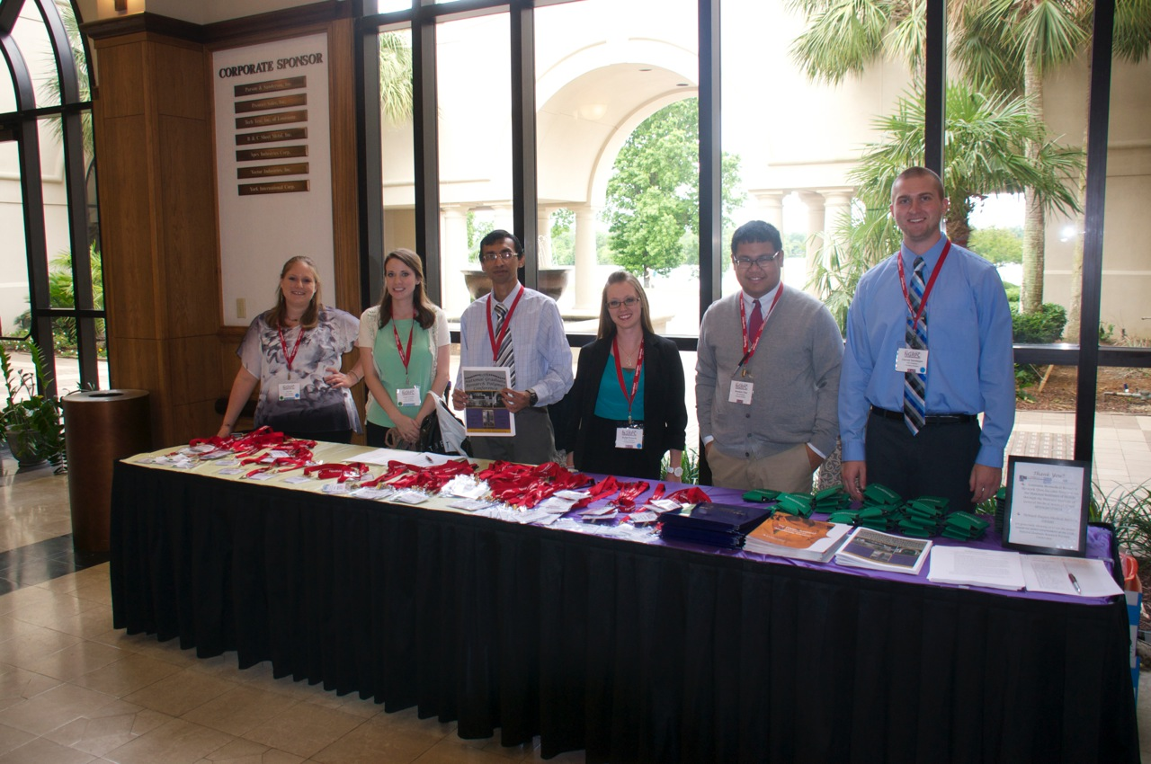
From Left: Elizabeth Jee, Leah Garber, Sourav Chatterje, Kylee Fazende, Brandon Chan and Garrett Sternhagen

