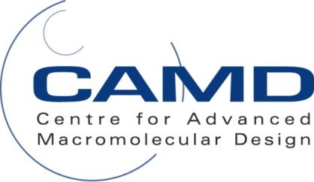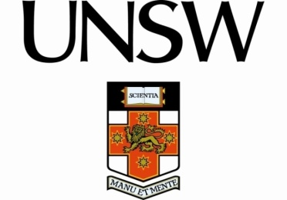

Postdoctoral Research Associate
Centre for Advanced Macromolecular Design (CAMD)

A Postdoctoral Research Associate position is available at The Centre for Advanced Macromolecular Design (CAMD) at the University of New South Wales (UNSW), Sydney, Australia, under the supervision of Prof Per Zetterlund in collaboration with Prof Sebastien Perrier (University of Warwick, UK) and Dr Graeme Moad (CSIRO, Melbourne). The overall aim of this project is to develop environmentally friendly and scalable methodology for synthesis of high-order multiblock copolymers using emulsion polymerization (RAFT). Qualifications: Ph.D. in polymer chemistry (preferably experience in RAFT and/or emulsion polymerization), ability to conduct independent research, and excellent communication skills. This fixed term full time position will be for one year initially, subject to renewal contingent on performance. Interested candidates should email a CV (incl. publication list) and the contact details of two academic referees to Prof Per Zetterlund (p.zetterlund@unsw.edu.au).

